|  |  |  |
| --- | --- | --- |
| **Amman Arab University** |  | **جامعة عمان العربية** |
| [**College of Information**](https://www.aau.edu.jo/en/academics/faculty-computer-science-and-informatics/about-college) **Technology** | **كلية تكنولوجيا المعلومات** |
| **Department of Software Eng.** | **قسم هندسة البرمجيات** |
| **Software Development and Documentation Section: 1****2st Semester 2024/2025** | **تطوير البرمجيات وتوثيقها الشعبة: 1**  **الفصل الدراسي الثاني 2024/2025** |

**AI- Care companion**

***Students:***

|  |  |
| --- | --- |
| Anas Mohammed Radwan Nakkash | 202120078 |
| Mohammed Hesham Abu Shabab | 202320820 |
| Ayham Ahmed Ramadan Yaghi | 202120737 |

***Supervisor:***

**Dr. Ala Abuthawabeh**

***Amman - Jordan***

**Table of Contents**

**1. System Planning ---------------------------------------------------- page 3**

**1.1 Introduction 3   
 1.2 Problem Statement and Project Scope 3**

**1.3 Business Case and Goals 3-4**

**1.4 Planning and Gantt Chart 4**

**1.5 SDLC Model 5**

**1.6 Use Case Diagram 5-6**

**1.7 UI (Mockup) 6**

**2. Requirements Gathering ----------------------------------------- page 7**

**2.1 Introduction 7**

**2.2 Functional Requirements 7-8**

**2.3 NON-Functional Requirements 9**

**2.4 Technical Requirements 10**

**1. System Planning**

**1.1 Introduction**

This project aims to develop an innovative healthcare chatbot, called "**AI-Care Companion**." This bot uses state-of-the-art GPT (Generative Pre-trained Transformer) models to provide personalized healthcare information and assistance to users. By enabling users to engage in natural language conversations, the project aims to provide accurate and reliable healthcare advice, tailored to each user's individual needs and preferences.

**1.2 Problem Statement and Project Scope**

**Problem Statement:** Individuals often face difficulty accessing reliable and timely healthcare information, especially when it comes to simple health inquiries or initial guidance. Searching for health information online can lead to inaccurate or confusing results, increasing users' anxiety and potentially leading to poor health decisions. Additionally, individuals may find it difficult to keep track of medications or receive personalized nutrition and exercise advice.

**Project Scope:** This project focuses on developing an AI-powered chatbot capable of understanding and processing users' health-related queries in natural language. The bot will provide personalized health information based on the user's health profile, including medical history, symptoms, and preferences. Key features will include initial symptom assessment, medication reminders, basic diet and exercise recommendations, and general health education. The project will not aim to provide a definitive medical diagnosis or replace a healthcare professional's consultation but rather serve as a first-line assistance and educational tool.

**1.3 Business Case and Goals**

**Business Case:** Developing an innovative healthcare chatbot represents an opportunity to address a growing need for reliable and accessible health information. This bot could provide users with the convenience of getting answers to their health questions anytime, anywhere. It could also help alleviate the burden on healthcare professionals by handling routine inquiries and directing users to appropriate resources. Additionally, the bot could encourage users to adopt better health behaviors by reminding them of medications and providing dietary and exercise recommendations.

**Goals: This project aims to achieve the following objectives:**

* Develop a healthcare chatbot based on state-of-the-art GPT models.
* Provide personalized and accurate health information to users based on their health profile. Enable users to interact with the bot easily and conveniently in their natural language.
* Provide a wide range of basic healthcare services, including initial symptom assessment, medication reminders, diet and exercise recommendations, and general health education.
* Ensure the security and privacy of user data according to industry standards.
* Create a user-friendly and intuitive user interface.

**1.4 Planning and Gantt Chart**

**The project development process will follow the following phases:**

Planning and Design: Defining detailed requirements, designing the system architecture and databases, and designing user interfaces.

Development: Programming and developing the various components of the system, including GPT model integration, natural language processing, and business logic.

Testing: Conducting comprehensive system tests to verify its functionality, performance, and security.

Deployment: Deploying the system and making it available to users.

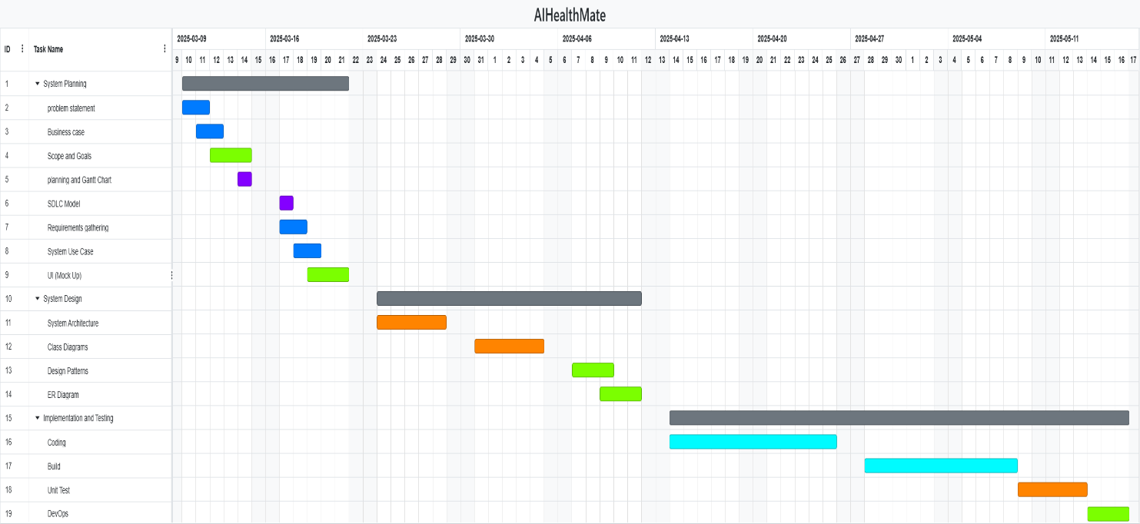Maintenance and Update: Monitoring system performance and implementing necessary updates and improvements.

**Figure 1: Gantt Chart of project**

**1.5 SDLC Model**

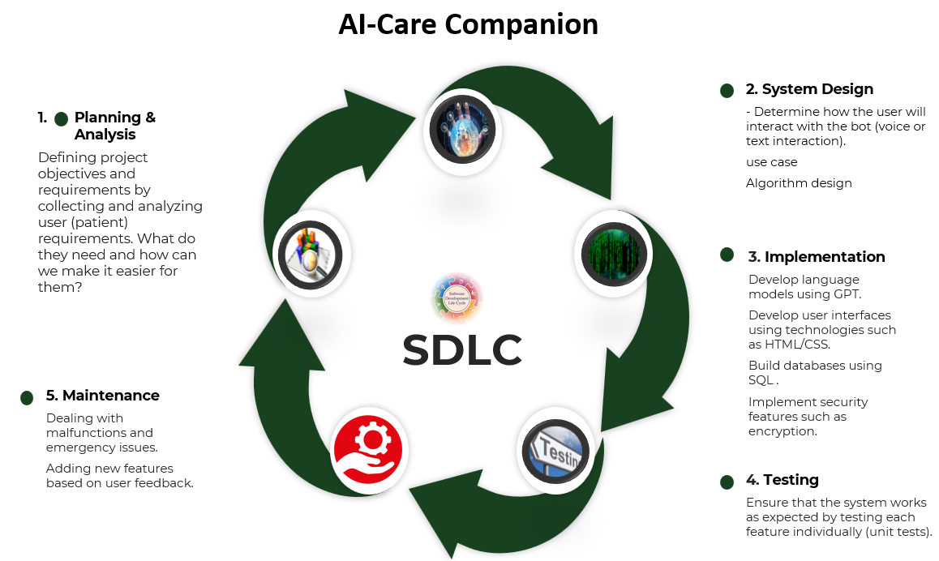 The image illustrates the software development life cycle (SDLC) of the AI-Care Companion project, a system that combines AI and healthcare technologies. It aims to provide simple medical consultations that help patients get quick answers without having to visit a doctor for every query. The project goes through five main phases: planning and analysis, system design, implementation, testing, and maintenance. This saves patients significant time and effort, while ensuring data security and continuously improving the user experience.

**Figure 2: SDLC Model**

**1.6 Use Case Diagram**

The main use case diagram will include the following interactions between the user and the chatbot system:

* **Log in/Register:** The user creates an account or logs in to the system.
* **Update Health Profile:** The user enters or updates their health information (medical history, symptoms, preferences).
* **Ask a Question/Start a Conversation:** The user enters a health inquiry in natural language.
* **Receive Answer/Information:** The user receives personalized health information or advice from the bot.
* **Request Medication Reminder**: The user requests and receives reminders for their medication.
* **Requesting Nutrition/Exercise Recommendations:** The user requests and receives basic nutritional and exercise recommendations.
* **Getting Educational Information:** The user requests information on specific health topics.

صورة تحتوي على نص, لقطة شاشة, رسم بياني, التصميم

قد يكون المحتوى المعد بواسطة الذكاء الاصطناعي غير صحيح.

**Figure 3: Use Case Diagram**

**1.7 UI (Mockup)**

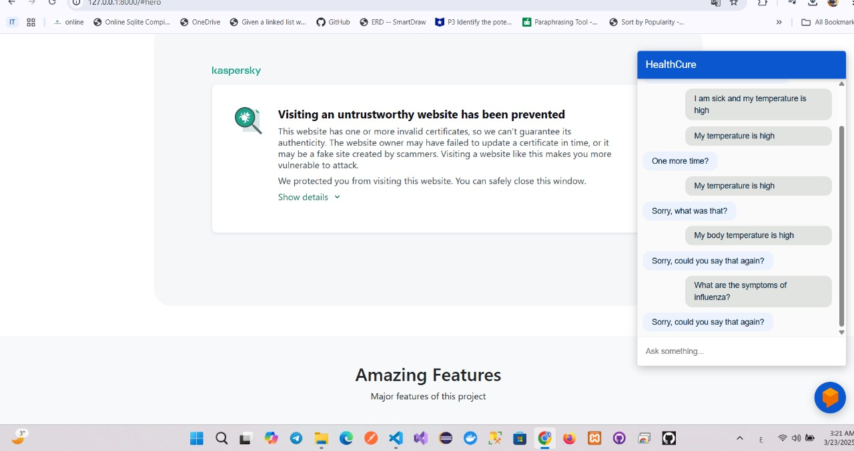**The user interface will feature a simple and user-friendly design. Key elements will include:**

* **Chat window:** To display conversations between the user and the bot.
* **Text input field:** To allow the user to type their queries.
* **Quick buttons/options:** To access common features such as requesting medication reminders or nutritional recommendations.
* **Viewing health profile:** To allow the user to view and edit their health information.
* **App/bot logo and name (AI-Care Companion).**

**2. Requirements Gathering**

* **Functional Requirements Document for AI-Care Companion**

**2.1. Introduction**

The AI-Care Companion project aims to provide an innovative healthcare chatbot system that assists users in managing their health by offering personalized information, guidance, and reminders. It leverages cutting-edge technologies like GPT to engage users in meaningful conversations, diagnose symptoms, recommend treatments, and help them adopt a healthier lifestyle. The primary goal is to improve access to accurate health information while maintaining privacy and security.

**2.2. Functional Requirements**

**2.2.A. User Profile Management**

* **Description:** Each user must have a personalized health profile that contains critical data such as age, gender, medical history, current medications, and other relevant health information.
* ***Functional Requirements:***
  + **Create Account:** Users should be able to create an account with basic information such as username, password, and email.
  + **Manage Profile:** Users can update their profile information, including medical history, current medications, and allergies.
  + **Data Validation:** Ensure accurate data input by validating fields such as age, gender, and medical conditions.
  + **Privacy and Security:** Implement robust data encryption and storage mechanisms to protect user data, with secure access only to the user and authorized personnel.
  + **User Authentication:** A secure login system should be implemented using OAuth2 or similar technology to allow for user authentication.
  + **Access Control:** Different permission levels should be established (admin, user, etc.) to manage the data access and update permissions.

**2.2.B. Intelligent Chatbot (GPT Integration)**

* **Description:** The chatbot will utilize a GPT model to provide intelligent responses based on the user's profile and symptoms described.
* **Functional Requirements:**
  + **Symptom Assessment:** The chatbot will allow users to describe their symptoms, and it will suggest potential conditions, treatments, or actions.
  + **Conversational Interface:** Provide a natural language interface where users can converse in real-time, asking questions and receiving information tailored to their health profile.
  + **Personalized Responses:** The chatbot will pull data from the user’s profile (e.g., medical history, age) to generate personalized, relevant responses.
  + **Multi-turn Dialogue:** The chatbot will maintain context in the conversation, handling multi-turn dialogues that involve follow-up questions, clarifications, or updates from the user.
  + **Health Recommendations:** The chatbot will provide evidence-based health recommendations, lifestyle changes, and preventive measures based on the user’s profile and interactions.
  + **Escalation:** If the chatbot determines that the user’s issue requires specialized attention, it will suggest a referral to a human doctor.

**2.2.C. Medication Reminder System**

* **Description:** The system should remind users to take their medications based on the prescriptions they have entered.
* **Functional Requirements:**
* **Medication Entry**: Users should be able to enter medication details such as dosage and schedule.
* **Reminder Notifications:** The system should send reminder notifications to take medications at the specified times.
* **Snooze or Confirmation Option:** Users should be able to either snooze the reminder or confirm that they have taken the medication.

**2.2.D. Dietary and Exercise Recommendations**

* **Description:** The system should provide personalized dietary and exercise recommendations based on the user's health condition.
* **Functional Requirements:**
* **Dietary Suggestions:** The system provides customized meal plans for the user based on their health condition.
* **Exercise Plans:** The system provides exercise routines that are suitable for the user's health condition.

**2.3. Non-Functional Requirements**

* Non-functional requirements are those that do not relate to the core functions of the system but focus on the system's quality attributes, such as performance, security, scalability, maintainability, etc. These requirements are essential to ensure that the system operates efficiently and meets user satisfaction.

**2.3.A. Performance Requirements**

* **Response Time:** The system should respond to any user inquiry within two seconds for 95% of interactions.
* **Availability:** The system should have an annual availability rate of 99.9%.
* **Load Handling:** The system should be able to handle 1000 concurrent users without significant impact on performance.

**2.3.B. Scalability**

* **Horizontal Scalability:** The system should be capable of scaling easily to accommodate additional users or health data without affecting performance.
* **Data Scalability:** The system should be able to store large volumes of data without compromising speed.

**2.3.C. Security**

* **Data Encryption:** All sensitive data must be encrypted using advanced encryption techniques such as AES-256.
* **Authentication:** The system should support two-factor authentication (2FA) for secure access.
* **Access Management:** Role-Based Access Control (RBAC) should be implemented in the system.

**2.3.D. Usability**

* **User Interface (UI):** The user interface should be simple and user-friendly for all age groups.
* **User Experience (UX):** The system navigation should be intuitive and provide clear instructions to users.

**2.3.E. Reliability**

* **Fault Tolerance:** The system should be able to quickly recover from failures such as network outages or server crashes.
* **Backup and Recovery:** Data backups should be performed regularly, and recovery should be fast and efficient.

**2.3.F. Maintainability**

* **Code Documentation:** The system should be built in a structured and maintainable way for future updates.
* **Monitoring and Alerts:** The system should include monitoring tools to track its status and send alerts in case of issues.

**2.3.G. Medical Accuracy**

* The system should rely on reliable and regularly updated medical guidelines to ensure the accuracy of the advice provided.

**2.4 Technical Requirements**

* **GPT Model:** Use the latest GPT models from OpenAI or another provider.
* **Frontend:** Use React for dynamic UI.
* **Backend:** Python .
* **Database:** Use MySQL to store product, user, and order data.
* **Application Programming Interface (API):** Develop APIs for communication between different components of the system.